Question 1: Software Development Methodology
Considering the specific situation and my role assigned to implement this project , I suggest utilizing the AGILE development methodology due to the following factors:
a) The first aspect relates to the nature of the requirements:
+ Flexibility: The initial requirements for the app are not clearly defined and may change slightly to adapt to market trends and user preferences during development.
+ Adaptability: Due to the vague nature of the requirements, there is a possibility that they may be modified or adjusted slightly during the development process to align with changing user preferences.
+ Covering both functional and non-functional aspects:The project includes various functional and non-functional requirements, as indicated by the description of specific features in the context. The intricate nature of the situation requires timely identification of any issues to fix them quickly, preventing expensive rework and avoiding disturbances to other modules.
b) The second aspect pertains to the Development team:
+ Team composition: The team comprises 4-6 extensive experience and skills developers and some support employees, rendering it well-suited for a project employing the Scrum development methodology.
+ Effective collaboration and communication skills : The team members all speak the same language, which helps them communicate easily and work efficiently together. This benefit greatly helps in finishing tasks on time.
+ Proficiency in designated roles and responsibilities: Every team member has a wealth of knowledge and experience in their designated tasks and duties.
+ Adaptability to changes: The team shows a strong capacity to adjust to evolving situations.
+ Time constraints and managers expected: The first version of the system is to be in use within 3 months and the project needs to be completely completed within 6 months.

c) The final aspect concerns user involvement in the project:
+ Project size: Medium
+ Extent of user engagement: Considered large due to the project's focus on internal FPT University users, primarily targeting Lecturers, Students and Academic staff. This significant user involvement stems from the project's scope.

In conclusion, considering the mentioned traits, I repeat my suggestion for utilizing the AGILE METHOD as the most appropriate strategy for this project. This decision is based on the project's medium size, complex set of needs, the crucial importance of detecting faults early, and the methodology's suitability for projects with vague customer requirements at the outset...
According to the details I previously gave, it seems that Scrum is the best model. This is my strategy for carrying it out.
To start, I collect all essential demands from team members in order to establish a product backlog.
Afterwards, my team and I convene for a sprint planning meeting in order to establish the objectives and the range of the upcoming sprint. We give importance to tasks in the backlog and set up a specific plan for the development tasks throughout the sprint.
+ I plan to divide the project into 4 sprints, each lasting one to two weeks.
- Sprint 1: Manage bus routes ( register bus routes, change bus routes, view currently registered bus routes).
- Sprint 2: synthesize weekly bus schedules (staff, lecturers, vehicles, records..).
- Sprint 3: Manage bus schedules (View bus schedules for weekly trips, approve weekly bus schedules, and view vehicle cost summary)
- Sprint 4: Manage schedules exported from FAP, transferring to the administrative department.
10-15p
Question 2: Testing Strategy
The type of testing that I recommend the team to do for this project is a combination of the type of
Testing Levels/Stages for the SBMS Project:
Unit Testing:
Tester Role: Developers
This initial testing level involves assessing individual software components to ensure their correctness.

Integration Testing:
Tester Role: Developers or a dedicated integration testing team
Focused on testing the interaction and compatibility of individual components to ensure seamless operation.

System Testing:
Tester Role: A dedicated team of testers
Comprehensive testing of the entire system to verify compliance with specified requirements.

User Acceptance Testing (UAT):
Tester Role: End users, such as lecturers, students, and academic staff
The final stage involves real users testing the system to ensure it meets real-world requirements and specifications.

Regression Testing:
Tester Role: A dedicated testing team or automated using software testing tools
Ensures that changes or enhancements to the system do not negatively impact existing functionalities.

Performance and Load Testing:
Tester Role: Specialized testers or engineers
Essential for ensuring high performance and reliability, evaluating the system under both normal and peak load conditions.

Question 3. Functional and Non-functional Requirements
Functional Requirements:
1. Lecturers and staff should be able to register bus routes.
2. Lecturers should be able to change bus routes
3. Lecturers should be able to view currently registered bus routes.
4. Administrative staff can synthesize weekly bus schedules of staff and lecturers.
5. Admin manager can view bus schedules for weekly trips, approve weekly bus schedules and view vehicle cost summaries.
Non-Functional Requirements:
1. Users should log in using their FU's email account on the Gmail platform.
2. The system must ensure high performance, robustness, and reliability.

Question 4 Use Case Diagram
register bus routes
synthesize weekly bus schedules




Chinh bán sr 40k

view vehicle cost summary

Admin staff
Lect


view currently registered bus routes.
view bus schedules
Lecturer

approve weekly bus schedules

Admin manager

SBMS system – use case diagram

Bị mất hình zz ta, dưới nha
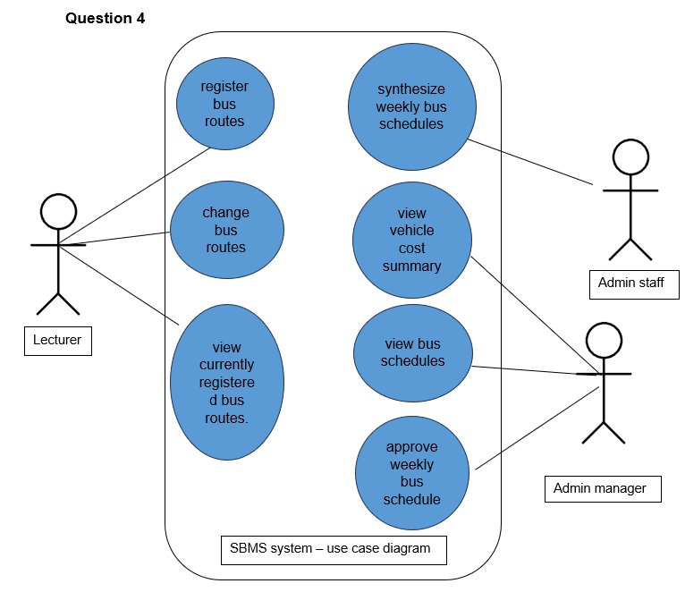

Question 5:Functional Test Cases 4 cái
Functional Test Cases for SBMS Use-Cases:
1. Use-case: registered bus routes
Test Case: Verify information register bus routes
Steps:
Log in as a lecturer.
Navigate to " register bus routes."
Fulfill information and confirm.
Expected Result: The system should successfully register bus routes, and update bus routes.
2. Use-case: Change bus routes
Test Case: Verify change bus routes work
Steps:
Log in as a lecturer.
Navigate to "Change bus routes."
Change information and choice and confirm
Expected Result: The system should notify message of change successfully and view bus routes
3. Use-case: View currently registered bus routes
Test Case: Verify currently registered bus routes
Steps:
Log in as a lecturer.
Navigate to "view registered bus routes."
Select a registered bus route to view.
Expected Result: The system should show all registered bus routes and show details if select a specific route
4. Use-case: Show Vehicle cost summary
Test Case: verify correct Vehicle cost summary
Steps:
Log in as an Admin manager.
Navigate to "summary."
Select a schedule of buses to view.
Expected Result: The system should calculate the correct cost and show the correct schedules.
Question 6: User Stories:
+ As a lecturer, I want to change the bus route which I have registered so that I can modify my fault and double-check to avoid mistakes in future.

+ As an admin manager, I want to view vehicle cost summary so that I can manage and give the most suitable plan for people

Question 7: Story Map: "Register Bus Route" and "Change Bus Route" Activities
User Activities | Register Bus route |  | Change Bus Boute
 | Register Bus route | View registered bus routes | Login | Change Bus Route | Vote routes to change | The review route has changed
Release 1 | Register for Role | View all registered bus routes | Login using phone | Change all routes | Vote routes by class | Show the old and new information
 | Register for prioritizes | View with sort by Alphabet | Login using email FPT | Change all routes by condition | Vote change routes by distance | Change routes again
 | Register for area | View with sort by prioritizes | Login using social media | Change a route | Vote change routes by priority | Statistics routes
 | Register by life condition | View with sort by distance | Forgot password | Change small information on the route | Assign presentation by user’s choice | The view details route has changed
Release 2 | Register for disease people | View with sort by class | Login with QR code | Automatic change follows schedules | AI calculated logically and auto-vote

